**Facility Use and Reservation Policy**

Salem allows individuals and groups from within and outside our congregation to use our facility. While the Salem facilities exist first for Salem UMC worship and ministry, we desire to extend hospitality to our community. Opening our doors to individuals, organizations, and groups (not for profit) is a way of showing our Christian love to the community.

**RESERVING THE FACILITY**

Scheduling of all facility usage, congregational or otherwise, must be done through the Church Office by filling out the Request for Facility Use Application Forms can be requested via email from [office@salemchurchcr.com](mailto:office@salemchurchcr.com) or at [salemchurch.life/facility-use](https://www.salemchurch.life/facility-use). Reservations requests **must** be made at least 30 days ahead of time. Please see Wedding [salemchurch.life/weddings](https://url.uk.m.mimecastprotect.com/s/tQtaCW7kluo14M9F1CVfoxNfI?domain=salemchurch.life) and Funeral [salemchurch.life/celebrate-life](https://url.uk.m.mimecastprotect.com/s/iZ8eCXom0trl985HMFwfWM76_?domain=salemchurch.life) policies for request information.

Each group requesting to use the facility shall designate a primary contact liaison. The liaison will be asked to consent on behalf of the group to the attached liability requirements and will also be responsible for ensuring that the use of the facility conforms to Salem's policies and that the facility is properly restored to its original condition. The reserving group’s liaison is responsible for and **must immediately** report to the designated Salem liaison any and all incidents that result in property damage (structural, electrical, plumbing, etc.) or personal injury.

**AVAILABILITY**

The facility is generally available during the following days and times:

|  |  |  |  |  |
| --- | --- | --- | --- | --- |
| Monday | 10am – 9pm |  | Friday | 9am – 9pm |
| Tuesday | 10am – 9pm |  | Saturday | 8am – 4pm |
| Wednesday* | 10am – 9pm |  | Sunday | 2pm – 8pm |
| Thursday | 10am – 9pm |  |  |  |

* First Wednesday of the month 10am-4pm

**BUILDING USE SET UP AND CLEAN UP**

*Set-up*

Chairs and tables are provided. Any desired set up beyond the standard footprint must be drawn out and specified on the Facility Use Request Application (**please note additional set up honorarium per schedule**). Extra tables and chairs will be set up and put away by authorized Salem personnel only.

*Clean-up*

The reserving group is responsible for assuring that the facility is brought to its original condition at the conclusion of the event. A checklist will be provided.

**BUILDING USE GUIDELINES**

• Smoking, vaping, and the consumption of alcohol are **NOT** allowed on Salem premises.

• Salem is unable to accept deliveries for any items related to outside events. The reserving group must bring all items during the time of set-up and schedule deliveries as such.

• Reserving group activities must remain in the agreed and designated facility areas requested. All other rooms and areas are considered off-limits.

• Children under 12 years old must be supervised at all times.

• The facility's fire exits cannot be blocked at any time, in any way.

• Music and dancing are permitted to appropriate music for a church setting (not promoting alcohol/drug use, violence, sexual behavior, etc.). Any questions related to this should be discussed with the designated Salem liaison.)

• Salem is not responsible for any loss or damage to the private property of individuals or organizations using the facility.

• Salem reserves the right to cancel any event due to unforeseen circumstances, in which case any honorarium paid will be refunded.

• Salem reserves the right to not accept a reservation if the group/event is not compatible or is contradictory to Salem's mission or vision or to the guidelines of The United Methodist Church.

**ADDITIONAL CONSIDERATIONS**

*Walk-through*

After the event has been approved, the appointed Salem liaison will reach out to the reserving group’s primary contact to finalize details and to schedule a walk through the facility before your event as needed/.

*Cancellations*

Events must be canceled by email to [office@salemchurchcr.com](mailto:office@salemchurchcr.com), as soon as possible or at least 3 days prior to the event

If your event needs to be rescheduled, Salem will assist in finding a mutually workable alternative date.

If a last minute decision to cancel has been made outside of Salem office hours, please contact your assigned church liaison. In such a case, if cancellation occurs after a requested set-up is complete, the set-up honorarium will not be refunded.

*Decorations*

Nothing can be taped, pinned, or nailed to the walls in any room. Easels are available for display use, requests can be made by contacting the Church Office.

*Audio Visual Equipment and Use*

Salem has a professional grade sound and video projection system in Fellowship Hall and the Sanctuary. A Salem assigned technician must be on site to set up and operate all audio and video equipment. **If the event requires use of this equipment, please detail all needs on the Request for Facility Use Application and a technician will be assigned to you ($75/hour, payable directly to technician per honorarium fee schedule attached)**.

Advanced planning discussion is required with AV technicians in order to coordinate and ensure compatible formatting with Salem’s systems. Set-up and sound checks with the technician must take place during the rental time frame.

All content must be in alignment with Salem’s mission and vision (as Salem is a church setting) and should be submitted to assigned Tech liaison at least one week in advance of event (via flash drive or shared drive).

*Musical instruments*

Sanctuary instruments include an organ and Clavinova (stage piano), and should only be used at the discretion of the organist or lead pastor. Salem can share referrals/contacts, and also offer a brief orientation for outside organists/pianists to familiarize them with equipment use. Musical instruments **may not be moved** without prior consent discussed with the lead pastor. Praise band instruments are not available for use.

*Food and Beverages*

Outside food and beverages are permitted (no alcohol) and kitchen may be utilized as needed (please see Kitchen Policy). Roasters may only be used in the kitchen (designated outlets are labeled “R”). Alcohol consumption, smoking, and vaping are prohibited on church property. No food or beverages are allowed in the Sanctuary or Narthex. All unused food and personal belongings must be removed.

**AVAILABLE LOCATIONS FOR USE**

* Fellowship Hall
* Kitchen
* Parlor
* Lower Level Classrooms

**Fellowship Hall**

Fellowship Hall can accommodate 110 people in auditorium seating or up to 95 with tables and chairs. There is no additional honorarium requested for using the existing furnishings and standard footprint in Fellowship Hall.

Fellowship Hall furnishings include:

*Standard footprint*

3 (3’) square wooden tables

3 (5’) round wooden tables

3 (27”) counter height wooden tables

30 matching wooden chairs

Serving table (3’ x 8’)

1 podium

Raised stage – 9.5’ x 11’

Restrooms

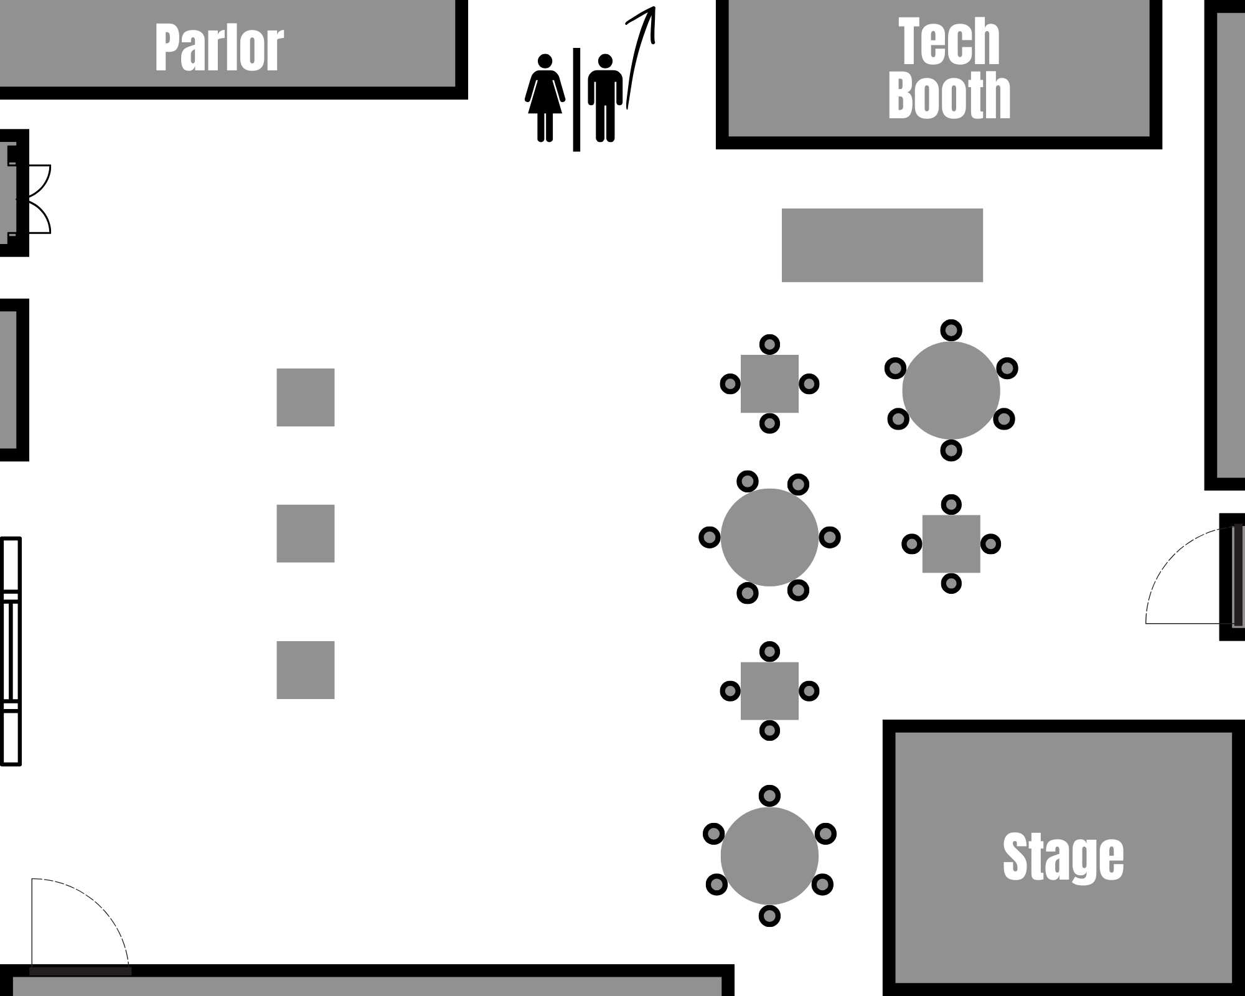

Additional banquet tables and chairs available:

*Set-up honorarium requested : $50

128 white resin folding chairs

3 rectangular, white, folding resin tables (3’x8’)

12 rectangular, white, folding resin tables (3’x6’)

*Kitchen*

Salem has a state-of-the-art kitchen complete with two refrigerators, two stoves/ovens, standard kitchen supplies, sink, and serving ware. Anyone wishing to utilize the kitchen for cooking will need a brief orientation, including the dishwasher procedure and hood suppression system (in case of emergency). All dishes must be washed and placed back in their original location. The kitchen must be returned to the same standard as it was found upon arrival, please see attached checklist.

*Parlor*

This welcoming room has a comfortable setting with plush couches and chairs around the perimeter of the room. The size is perfect for a small and intimate gathering. The Parlor is equipped with a television and a DVD player.

*Lower Level Rooms*

Several classrooms/conference rooms are available for use in our Lower Level. Rooms available include two conference/classrooms and a large youth room, complete with a ping-pong table and foosball table.

Room 6 Room 5

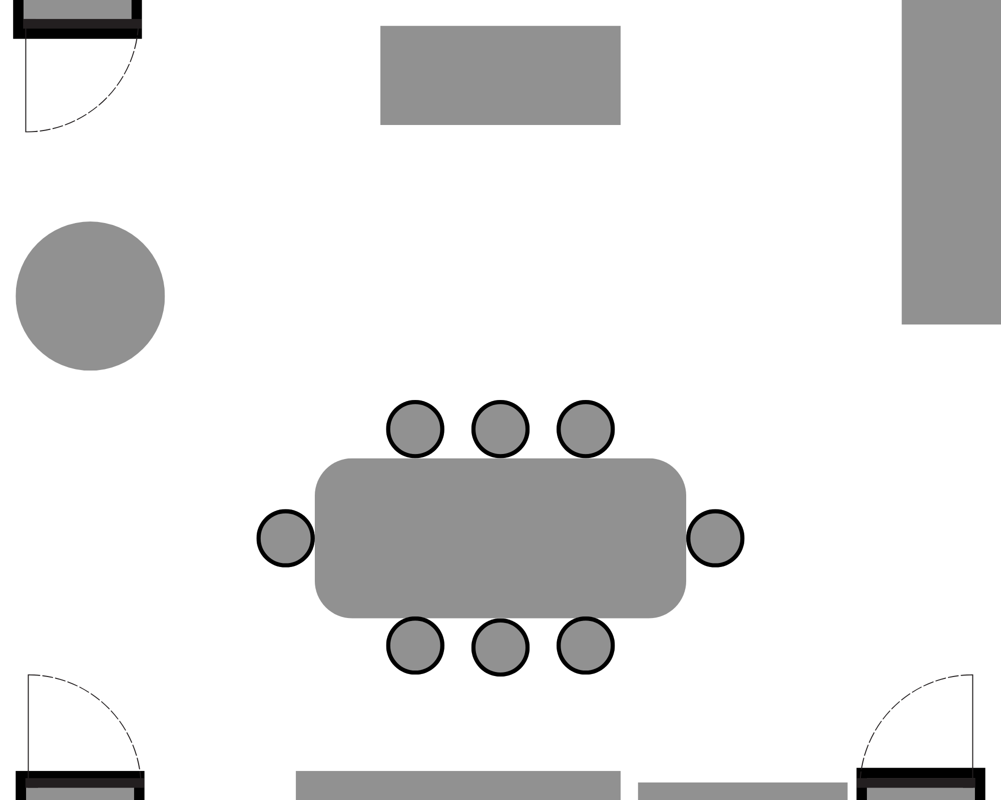 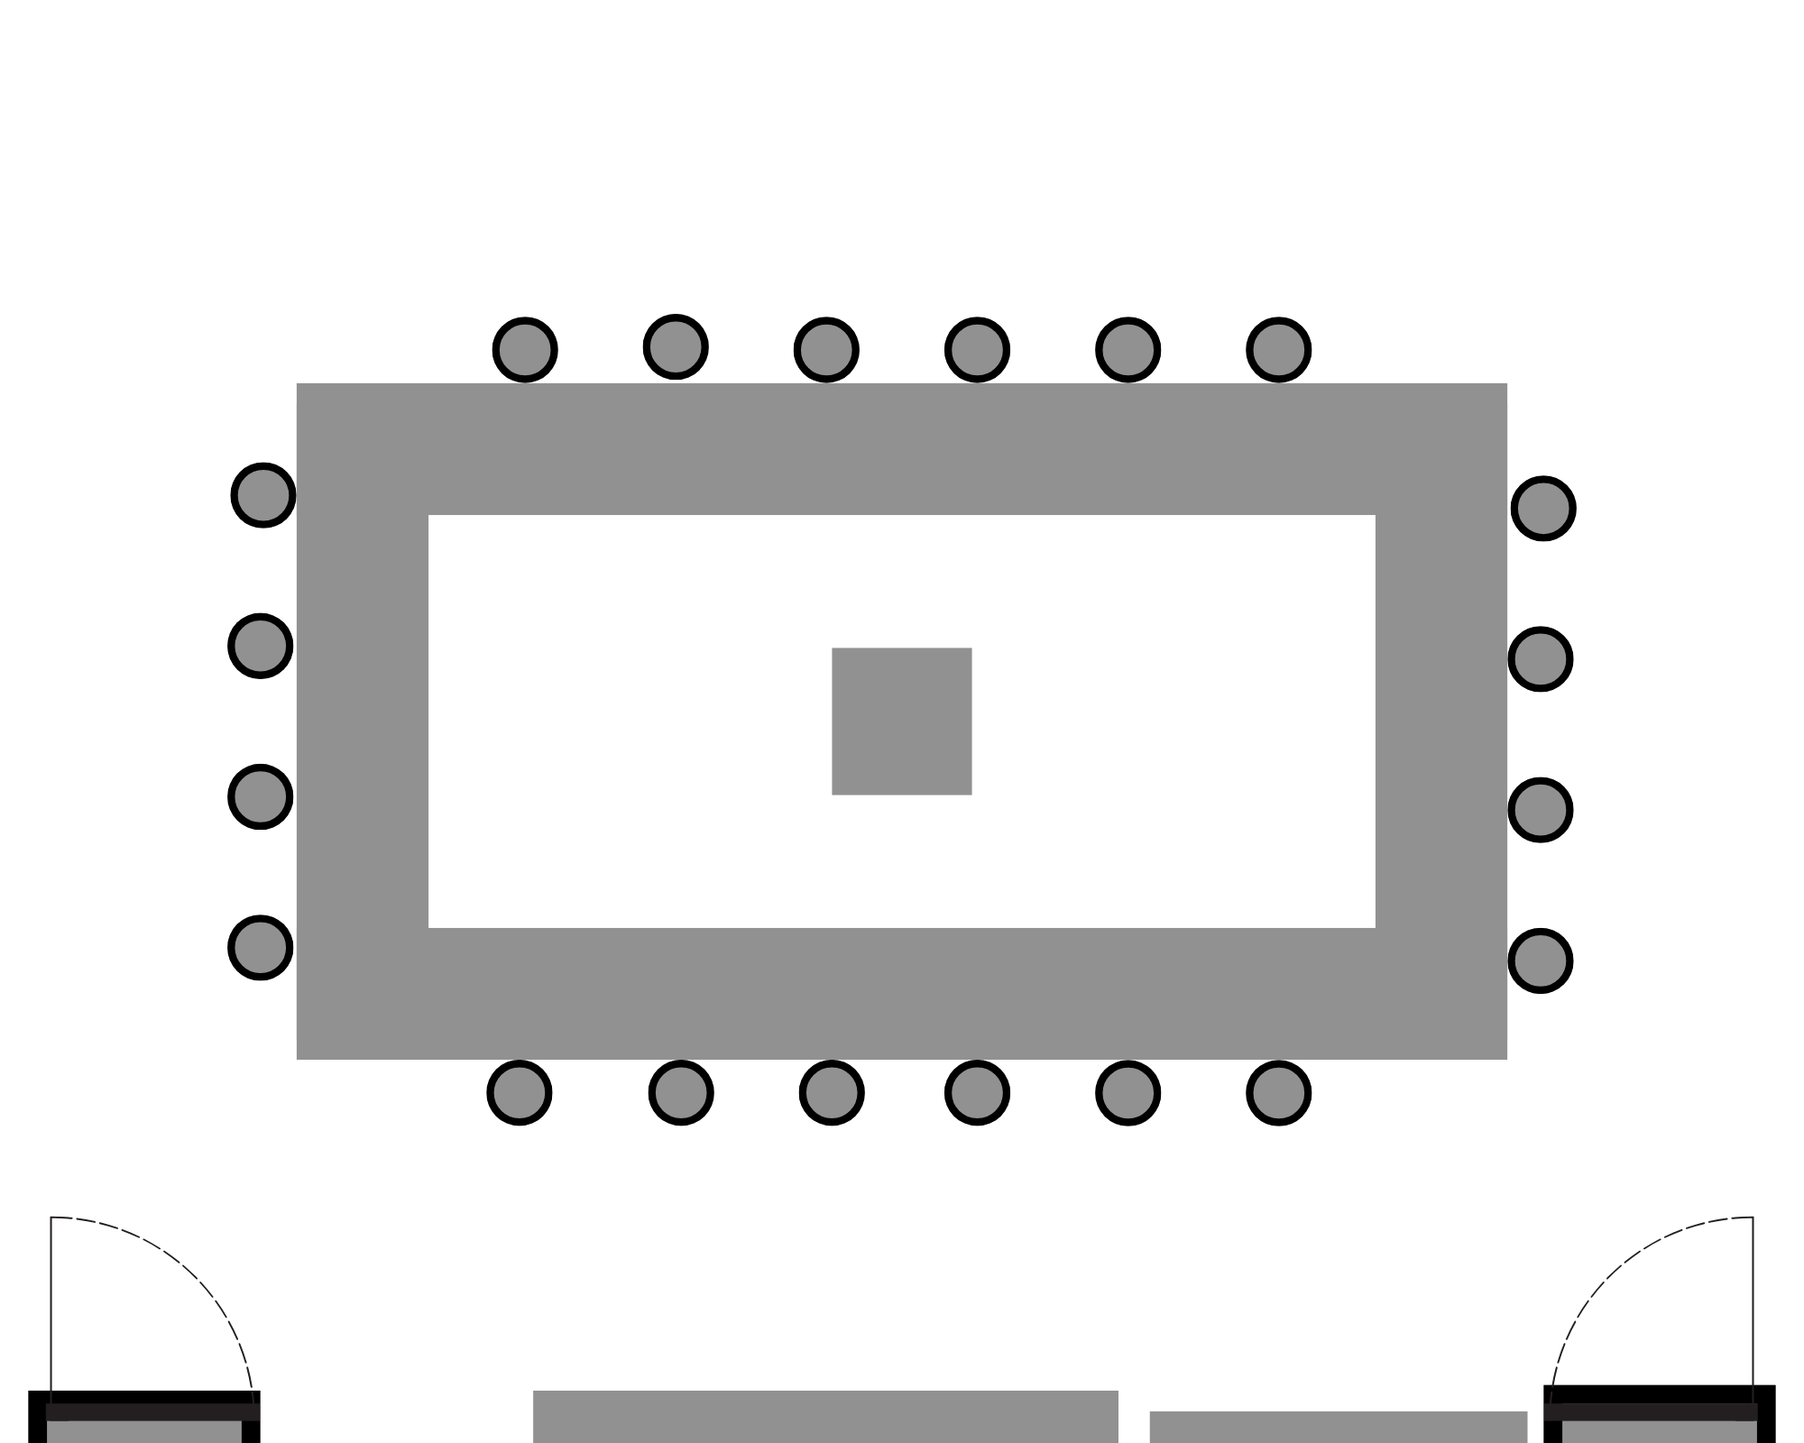

Youth Room

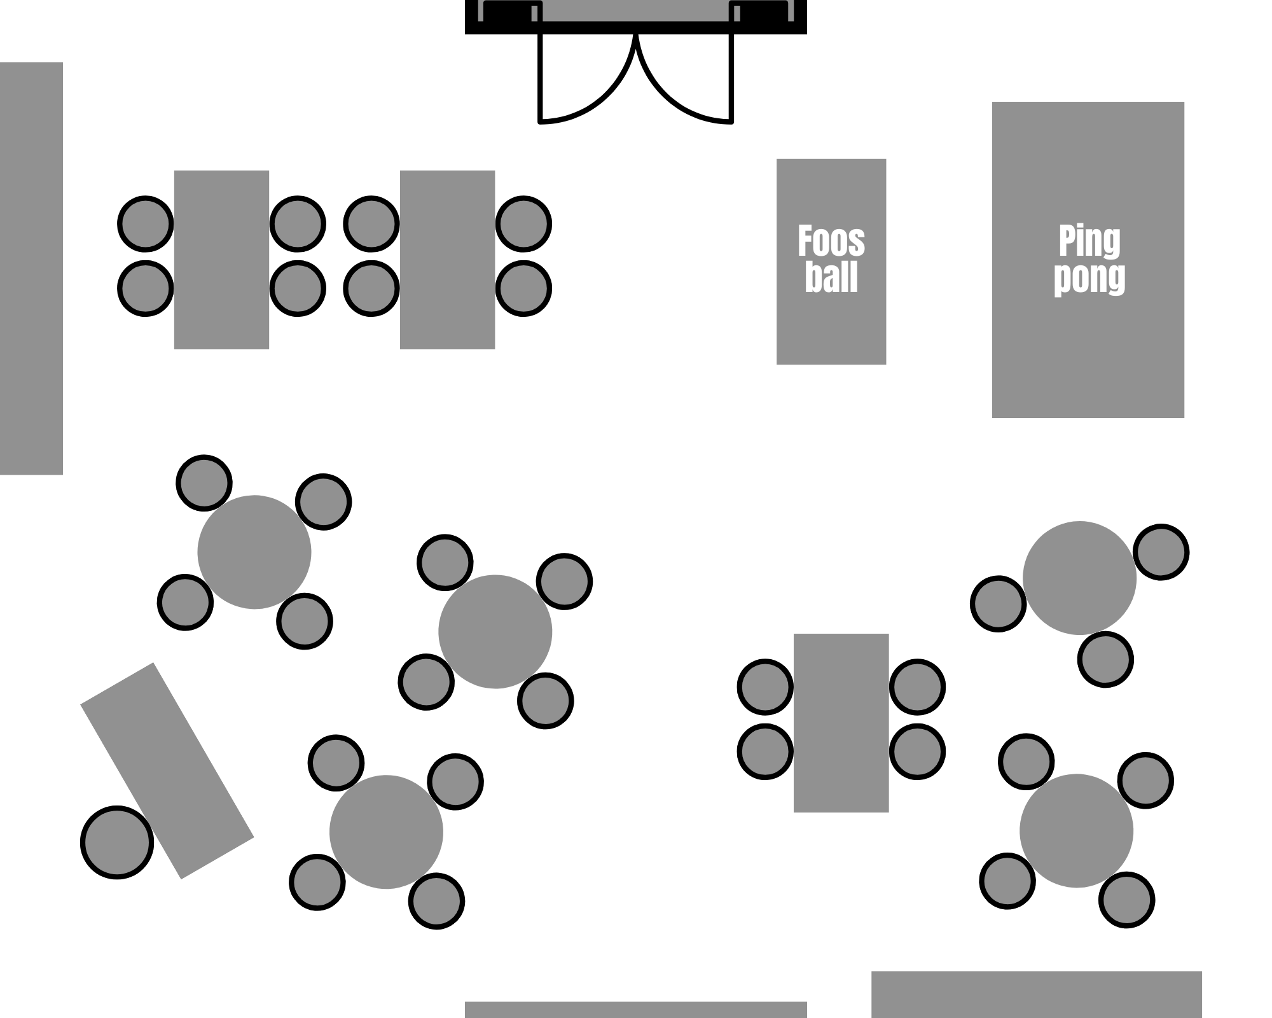

*Updated 5/15/2025*



**Facility Use – Recommended Honorarium Schedule**

|  |  |  |
| --- | --- | --- |
| Room Reservation - no kitchen use | 1-3 Hours | 3+ hours |
| Small groups (30 or less) | $50 | $100 |
| Large groups (110 max) | $100 | $150 |
|  |  |  |
| Room Reservation - with kitchen use | 1-3 Hours | 3+ hours |
| Small groups (30 or less), with kitchen use | $100 | $150 |
| Large groups (110 max), with kitchen use | $150 | $200 |
|  |  |  |
|  |  |  |
| Additional Fees | Fee | Payable to |
| Audio/Visual Technician | $75/hour | Technician |
| Additional Room Furnishing Set Up | $50 | Salem UMC UMM |

Unless otherwise specified, checks should be made payable to Salem United Methodist Church. **All payments are due to the Salem church office at least one week in advance of reservation date.**