**Facility Use Application**

Name of group and/or event: ____________________________________________________________

DESCRIPTION OF EVENT

|  |  |
| --- | --- |
| Date(s) requested: ______________________________ | Estimated Attendance: ____________ |
| Event time: __________ AM/PM to __________ AM/PM |  |
| Building unlock time: _________ AM/PM | Building lock time: _________ AM/PM |

**AREA/S REQUESTED** (please check all that apply)

|  |  |
| --- | --- |
| * Sanctuary * Fellowship Hall/Parlor * Kitchen | * Lower Level Classroom 6 * Lower Level Classroom 5 * Lower Level Youth Room |

**PRIMARY CONTACT PERSON FOR EVENT**

Name: ____________________________________ Phone: (_______) ___________________

Email: __________________________________________________

Special requests* (alternative arrangement of tables/chairs, microphones, etc.):

_____________________________________________________________________________________

Technical requests* (AV needs):

_____________________________________________________________________________________

I have read and agree to the stated terms, conditions, and policies* provided by Salem United Methodist Church.

Signature __________________________________________Date ____________________

*Please utilize diagram on Page 2 for special Fellowship Hall set up requests. Please reference Building Use Policy relating to honorarium recommendations for special requests.

Fellowship Hall Standard :

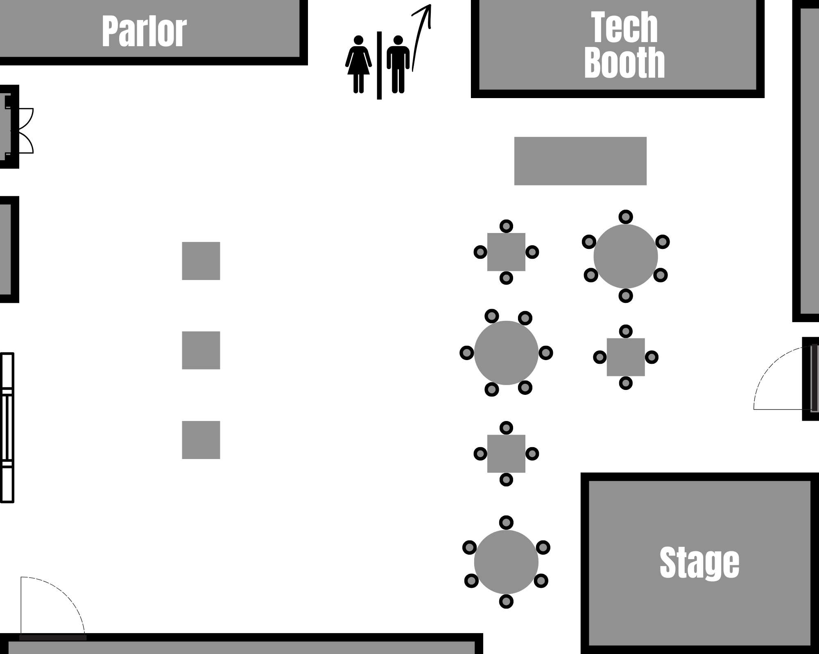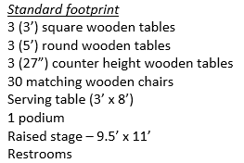

Fellowship Hall Request :

